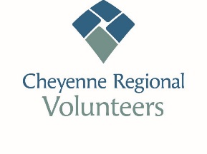Welcome! We are pleased that you are interested in joining our Volunteer Group a Cheyenne Regional Medical Center. Volunteer services are mutually beneficial to CRMC as well as our volunteers.
Student – 14yrs-18yrs

Please fill in the application form and background release.
Return form to: Cheyenne Regional Medical Center (CRMC)

New volunteers to CRMC:

- Please complete the application.
When completed return to Volunteer Coordinator at CRMC.

- Complete your orientation meeting. Review of the guidelines and safety procedures.
Receive health screening form, make your appointment.

- Complete a health screening, required by CRMC
(Paid for by CRMC)

For better communication please fill in current email and phone number. Thank you!!

If you have questions or need additional information contact, Brenna Heaton 307-633-7513 or brenna.heaton@crmcwy.org

We are looking forward to you joining our Cheyenne Regional
Medical Center Volunteer Group.

Please return application and background consent to:
Cheyenne Regional Medical Center Volunteers
214 E. 24th St
Cheyenne, WY 82001
Or email to brenna.heaton@crmcwy.org
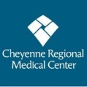

Volunteer Application

Applicant Information
Full Name: |  |  |  | Date:
 | Last | First | M.I.

Address:
 | Street Address | Apartment/Unit #

 | City | State | ZIP Code

Phone: |  | Email

Date of Birth:__________________
Do you have Volunteer experience? | YES | NO | If yes, where? _________________________

Current or past employment.
Have you ever been convicted of a felony or a misdemeanor? | YES | NO

If yes, explain:
Conviction of a crime is not an automatic bar from volunteering.

As a Volunteer of CRMC
- I will be punctual and conscientious in fulfillment of my duties and accept supervision graciously.
- I will conduct myself with dignity, courtesy and consideration.
- I will keep information heard directly or indirectly confidential about patients, family members or doctors.
- I will report any problems, criticisms or suggestions to a Volunteer Board Member/Volunteer Coordinator.
- I will uphold the traditions and standards of Cheyenne Regional Medical Center.
- I understand that to remain an active Volunteer I will be require to serve a minimum of 25 per year.
- I understand that by not adhering to the CRMC Volunteering Standard I can be dismissed from the Volunteer Core.
Print name: _______________________________________________________
Signature: ________________________________________________________
Parent Signature:__________________________________________________ Date: _______________________

